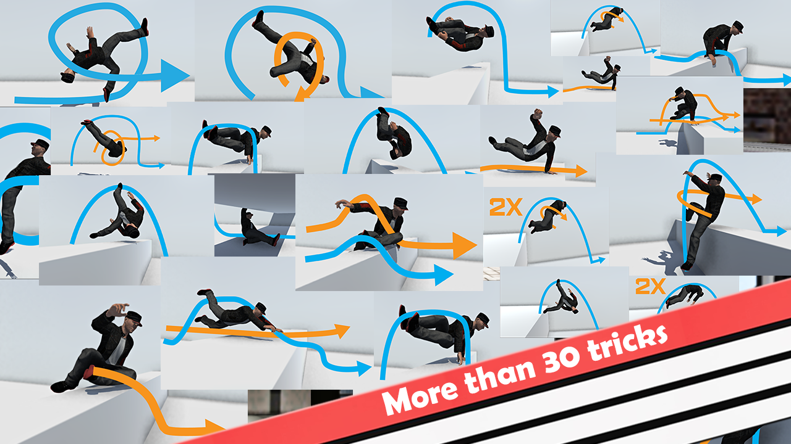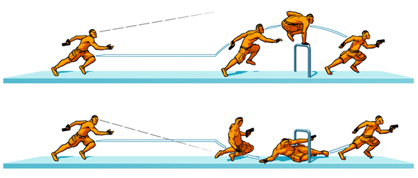

convicted



*a stylised white and black aesthetic with elements of red or blue.*

*this could potentially attract the target audience of males within the age range of 16-25.*

*Using this type of colour scheme would allow for more complex and confusing map layouts to add more of a challenge.*

art style

the hook

*A mix of fast game play with quick music and fast respawns.*

*This means if the character dies the player is constantly in the action.*

*Different Power-Ups would be available to allow for a sense of player progression.*

*2D Action Platformer.*

*fast pace parkour.*

*escape from the police due to a crime you have committed.*

*both inside and outside for extra challenge.*